Hoe geef ik line numbers weer.

Je klikt op **tools** via je menu balk en dan op **options**.

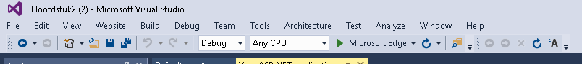

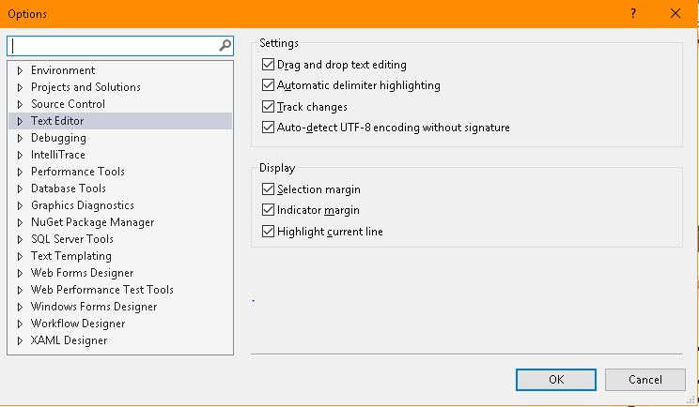Klik daarna op **text editor** .Je ziet nu meer balkjes onder **text editor** verschijnen.

Klik op **All Languages** en dan op **General** dan verschijnt er de scherm die u hieronder ziet.

Hier zie je ook tevens de optie **Line numbers** vink hem aan.

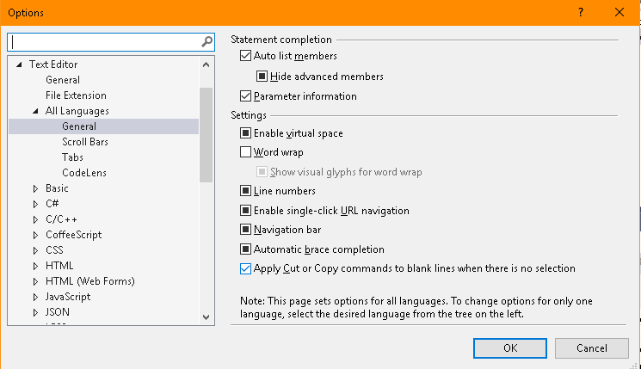

1.2

Hoe maak je dat je vs bestand op een andere locatie opslaat.

Je klikt op **tools** via je menu balk en dan op **options**.



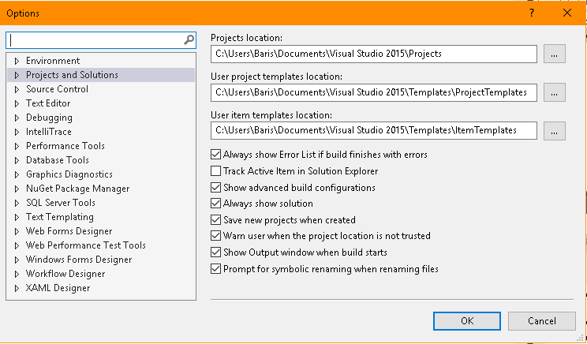Klik daarna op **Project and Solutions.**

Je zie nu de optie **General** klik er op.

Je kan nu de locatie waar je je bestanden opgeslagen worden wijzigen door de **Project location** te veranderen.

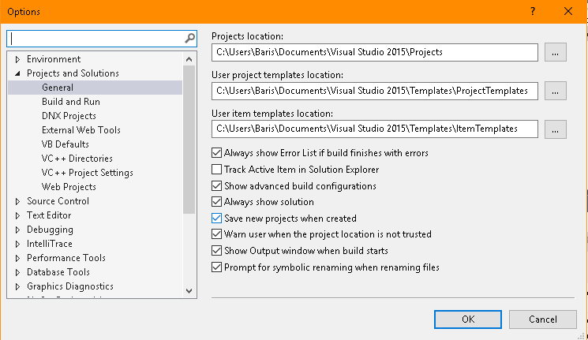

Opdracht 1.3

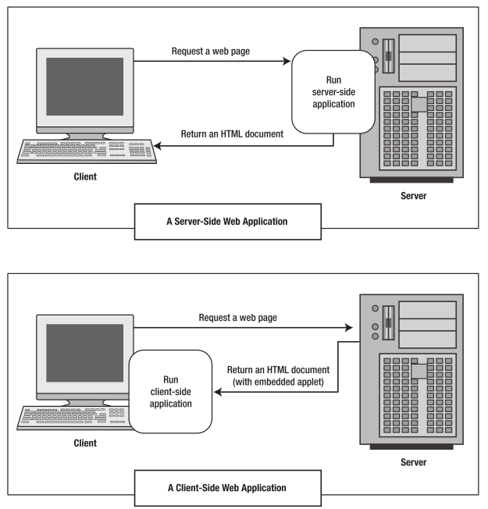

Server-side web Application:

The **Server** - This party is responsible for **serving** pages.

languages

*ASP  
*python

The **Client** - This party requests pages from the **Server**, and displays them to the user. In most cases, the client is a **web browser**.

*Html  
*css

Opdracht 1.4

While PHP and Visual Basic .NET have similar language constructs, they are very different syntax for them. Since Visual Basic .NET is built upon an OOP model, variable declaration is much more rigorous than in PHP where a variable is declared simply by adding a dollar sign ($) before the variable name.

In Visual Basic .NET you declare a variable by specifying its name and characteristics. The declaration statement for variables is the Dim keyword. Its location and contents determine the variable's characteristics. Variables have levels such as local and module, data types, lifetimes and finally accessibility.

While this approach may seem more complex at first than variable assignment in PHP it actually makes a developer's life easier. ASP.NET focuses on helping developers build robust applications—and specifying data types makes tasks such as variable clean up, debugging, exception and error handling, and code maintenance much easier.

Source:

https://msdn.microsoft.com/en-us/library/aa479002.aspx

